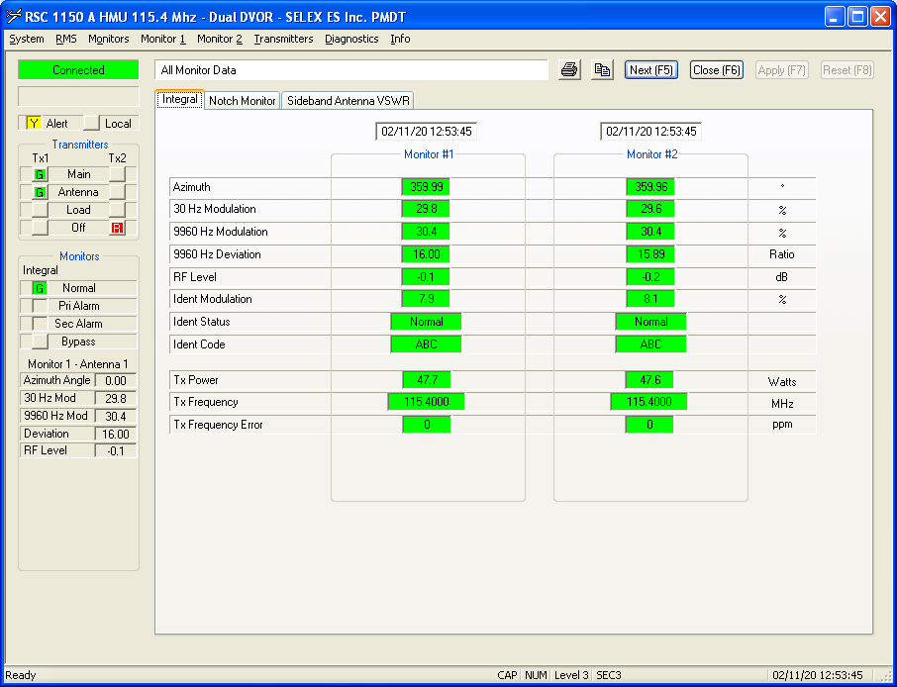

H1[12:53:42.024] F8 F8 C0 F0 08 00 00 00 00 97 00 14 02 0B 0C 35 2C 00 00 C1 A7 00 00 01 87 06 2B 05 09 95 00 00 00 00 00 00 00 00 00 00 00 00 00 00 00 00 00 00 00 00 00 01 00 2A 01 30 01 40 06 FF FF 00 00 00 00 00 00 00 00 00 00 00 00 00 00 00 00 00 00 00 00 00 00 00 00 00 00 00 0E 00 00 00 00 00 00 00 00 00 00 00 00 00 00 00 00 00 00 00 00 00 00 00 00 00 00 00 00 00 00 00 00 00 00 00 00 00 00 00 00 00 00 00 00 00 00 00 00 00 00 00 00 00 00 00 00 00 00 00 00 00 83 00 00 00 1F E8 42 78 6F FB 2D 35 AA 79

Alert

Main Tx1

Ant Tx1

Tx1 ON

Tx2 OFF

DualEquipment ON

Vor eMain

VOR Go condition

Ngay 11 thang 2 nam 20 Gio 12 Phut 53 Giay 44

AzimuthAngle: 1

Mod30Hz: 298

Mod9960Hz: 304

Deviation :1600

RFlevel: -1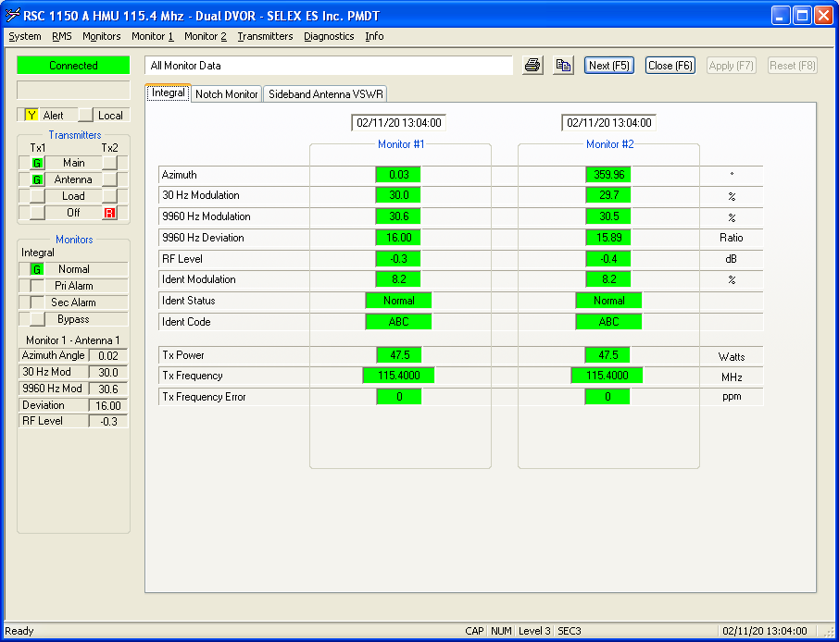

H7[13:03:59.593] F8 F8 C0 F0 08 00 00 00 00 97 00 14 02 0B 0D 04 02 00 00 C1 A7 00 00 01 87 06 2B 05 09 95 00 00 00 00 00 00 00 00 00 00 00 00 00 00 00 00 00 00 00 00 00 02 00 2B 01 32 01 40 06 FD FF 00 00 00 00 00 00 00 00 00 00 00 00 00 00 00 00 00 00 00 00 00 00 00 00 00 00 00 0E 00 00 00 00 00 00 00 00 00 00 00 00 00 00 00 00 00 00 00 00 00 00 00 00 00 00 00 00 00 00 00 00 00 00 00 00 00 00 00 00 00 00 00 00 00 00 00 00 00 00 00 00 00 00 00 00 00 00 00 00 00 1F 00 00 00 5A D9 43 78 6F FB 2D 35 7D 51

Alert

Main Tx1

Ant Tx1

Tx1 ON

Tx2 OFF

DualEquipment ON

Vor eMain

VOR Go condition

Ngay 11 thang 2 nam 20 Gio 13 Phut 4 Giay 2

AzimuthAngle: 2

Mod30Hz: 299

Mod9960Hz: 306

Deviation :1600

RFlevel: -3

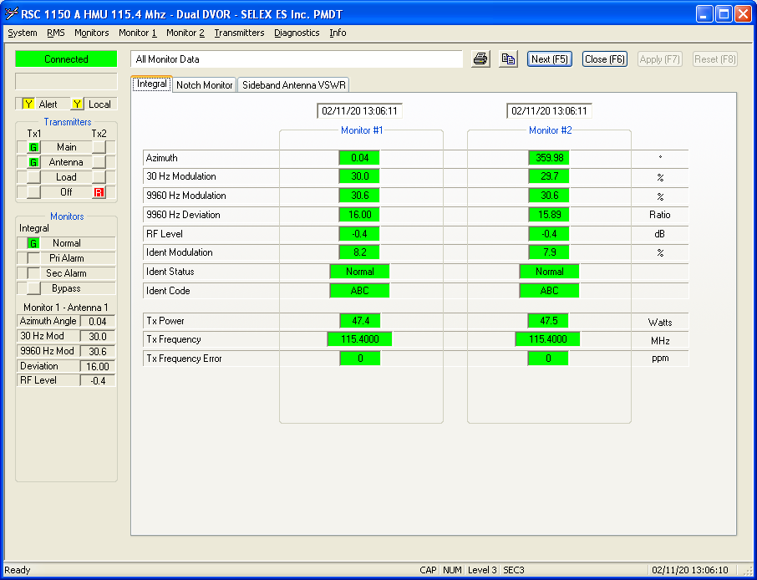

H8[13:06:06.314] F8 F8 C0 F0 08 00 00 00 00 97 00 14 02 0B 0D 06 08 00 00 C1 A7 00 00 11 87 06 2B 05 09 95 00 00 00 00 00 00 00 00 00 00 00 00 00 00 00 00 00 00 00 00 00 02 00 2C 01 32 01 40 06 FC FF 00 00 00 00 00 00 00 00 00 00 00 00 00 00 00 00 00 00 00 00 00 00 00 00 00 00 00 0E 00 00 00 00 00 00 00 00 00 00 00 00 00 00 00 00 00 00 00 00 00 00 00 00 00 00 00 00 00 00 00 00 00 00 00 00 00 00 00 00 00 00 00 00 00 00 00 00 00 00 00 00 00 00 00 00 00 00 00 00 00 55 00 00 00 DB 0A 44 78 6F FB 2D 35 61 70

Alert

Local

Main Tx1

Ant Tx1

Tx1 ON

Tx2 OFF

DualEquipment ON

Vor eMain

VOR No Go condition ALARM

Ngay 11 thang 2 nam 20 Gio 13 Phut 6 Giay 8

AzimuthAngle: 2

Mod30Hz: 300

Mod9960Hz: 306

Deviation :1600

RFlevel: -4

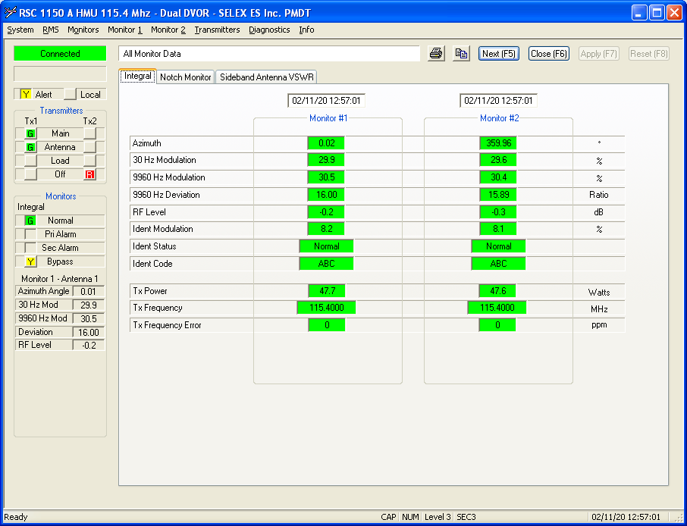

H2[12:55:53.744] F8 F8 C0 F0 08 00 00 00 00 97 00 14 02 0B 0C 37 38 00 00 C1 A7 00 01 01 97 06 2B 05 09 95 00 00 00 00 00 00 00 00 00 00 00 00 00 00 00 00 00 00 00 00 00 03 00 2B 01 30 01 40 06 FE FF 00 00 00 00 00 00 00 00 00 00 00 00 00 00 00 00 00 00 00 00 00 00 00 00 00 00 00 0E 00 00 00 00 00 00 00 00 00 00 00 00 00 00 00 00 00 00 00 00 00 00 00 00 00 00 00 00 00 00 00 00 00 00 00 00 00 00 00 00 00 00 00 00 00 00 00 00 00 00 00 00 00 00 00 00 00 00 00 00 00 E0 00 00 00 93 1B 43 78 6F FB 2D 35 B7 5E

Alert

Main Tx1

Ant Tx1

Tx1 ON

Tx2 OFF

DualEquipment ON

Integral Bypass

Vor eMain

VOR Go condition

Ngay 11 thang 2 nam 20 Gio 12 Phut 55 Giay 56

AzimuthAngle: 3

Mod30Hz: 299

Mod9960Hz: 304

Deviation :1600

RFlevel: -2

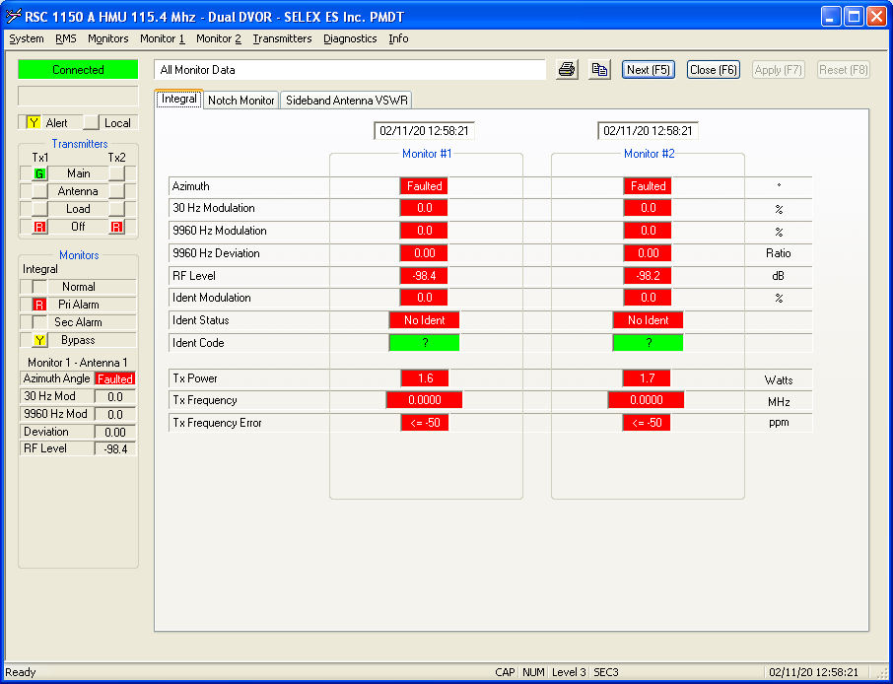

H3[12:58:18.999] F8 F8 C0 F0 08 00 00 00 00 97 00 14 02 0B 0C 3A 15 00 00 C1 A7 40 01 01 83 06 2B 05 09 95 00 00 00 00 00 00 00 00 00 00 00 00 00 00 00 00 00 00 00 00 00 FF FF 00 00 00 00 00 00 28 FC 00 00 00 00 00 00 00 00 00 00 00 00 00 00 00 00 00 00 00 00 00 00 00 00 00 00 00 0E 00 00 00 00 00 00 00 00 00 00 00 00 00 00 00 00 00 00 00 00 00 00 00 00 00 00 00 00 00 00 00 00 00 00 00 00 00 00 00 00 00 00 00 00 00 00 00 00 00 00 00 00 00 00 00 00 00 00 00 00 00 BA 00 00 00 50 54 43 78 6F FB 2D 35 44 1D

Alert

Main Tx1

Ant Tx1

Tx1 OFF

Tx2 OFF

DualEquipment ON

Integral PriAlarm

Integral Bypass

eOFF

VOR No Go condition ALARM

Ngay 11 thang 2 nam 20 Gio 12 Phut 58 Giay 21

AzimuthAngle: 65535

Mod30Hz: 0

Mod9960Hz: 0

Deviation :0

RFlevel: -984

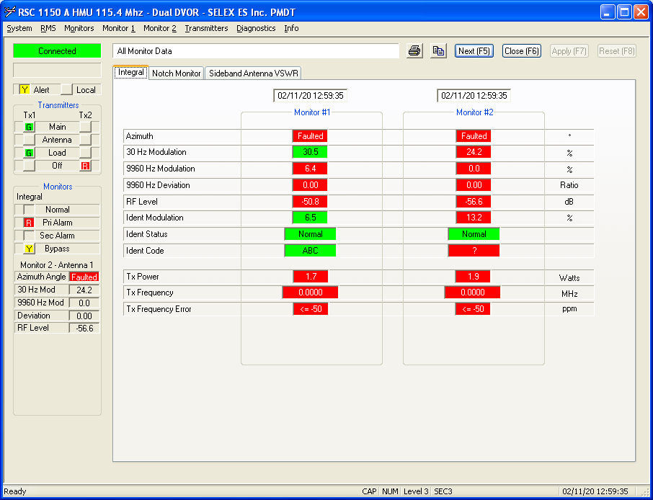

H4[12:59:35.629] F8 F8 C0 F0 08 00 00 00 00 97 00 14 02 0B 0C 3B 26 00 00 C1 87 40 01 01 86 06 2B 05 09 95 00 00 00 00 00 00 00 00 00 00 00 00 00 00 00 00 00 00 00 00 00 FF FF F2 00 74 00 00 00 CA FD 00 00 00 00 00 00 00 00 00 00 00 00 00 00 00 00 00 00 00 00 00 00 00 00 00 00 0E 00 00 00 00 00 00 00 00 00 00 00 00 00 00 00 00 00 00 00 00 00 00 00 00 00 00 00 00 00 00 00 00 00 00 00 00 00 00 00 00 00 00 00 00 00 00 00 00 00 00 00 00 00 00 00 00 00 00 00 00 00 00 4F 00 00 00 3E 72 43 78 6F FB 2D 35 BB 17

Alert

Main Tx1

**Ant Tx2**

Tx1 ON

Tx2 OFF

Tx1 LOAD

DualEquipment ON

Integral PriAlarm

Integral Bypass

eOFF

VOR No Go condition ALARM

Ngay 11 thang 2 nam 20 Gio 12 Phut 59 Giay 38

AzimuthAngle: 65535

Mod30Hz: 242

Mod9960Hz: 116

Deviation :0

RFlevel: -566

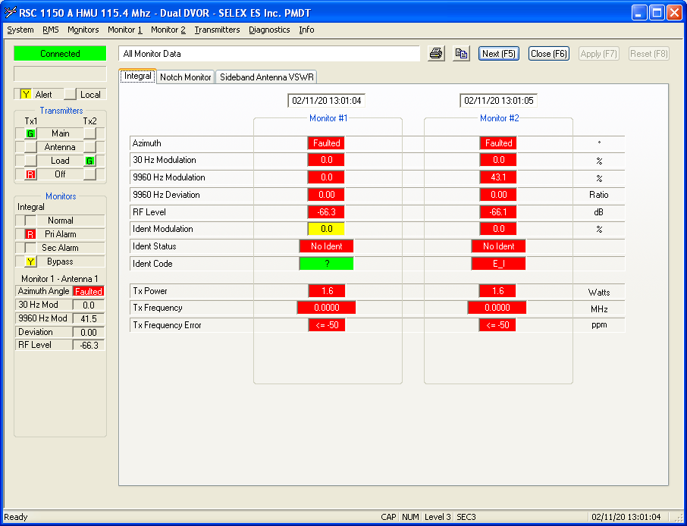

H5[13:01:02.291] F8 F8 C0 F0 08 00 00 00 00 97 00 14 02 0B 0D 01 04 00 00 C1 A7 40 01 01 8B 06 2B 05 09 95 00 00 00 00 00 00 00 00 00 00 00 00 00 00 00 00 00 00 00 00 00 FF FF 00 00 9F 01 00 00 69 FD 00 00 00 00 00 00 00 00 00 00 00 00 00 00 00 00 00 00 00 00 00 00 00 00 00 00 00 0E 00 00 00 00 00 00 00 00 00 00 00 00 00 00 00 00 00 00 00 00 00 00 00 00 00 00 00 00 00 00 00 00 00 00 00 00 00 00 00 00 00 00 00 00 00 00 00 00 00 00 00 00 00 00 00 00 00 00 00 00 00 35 00 00 00 19 94 43 78 6F FB 2D 35 5D 5C

Alert

Main Tx1

Ant Tx1

Tx1 OFF

Tx2 ON

Tx2 LOAD

DualEquipment ON

Integral PriAlarm

Integral Bypass

eOFF

VOR No Go condition ALARM

Ngay 11 thang 2 nam 20 Gio 13 Phut 1 Giay 4

AzimuthAngle: 65535

Mod30Hz: 0

Mod9960Hz: 415

Deviation :0

RFlevel: -663

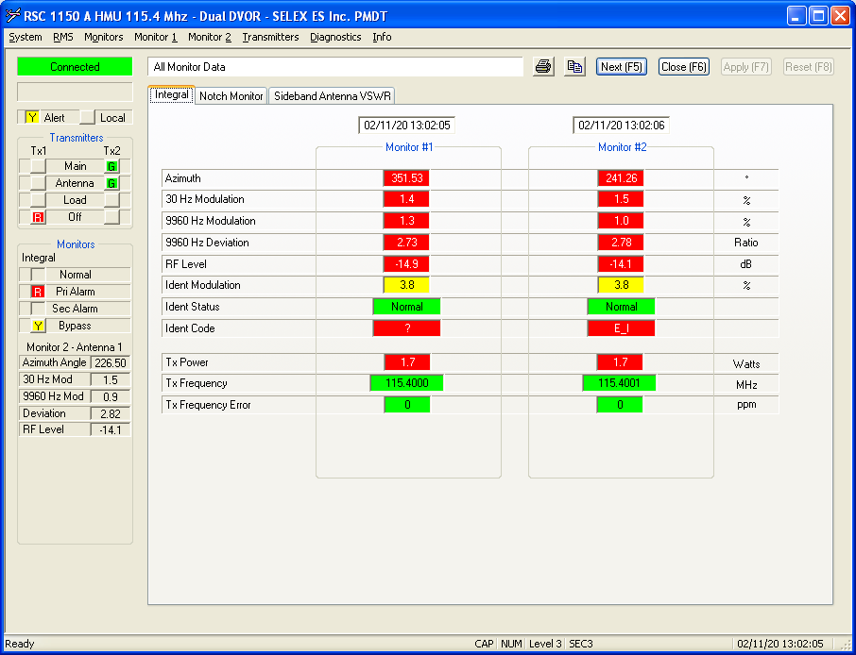

H6[13:02:04.880] F8 F8 C0 F0 08 00 00 00 00 97 00 14 02 0B 0D 02 06 00 00 C1 87 40 01 01 88 06 2B 05 09 95 00 00 00 00 00 00 00 00 00 00 00 00 00 00 00 00 00 00 00 00 00 DF 4D 0F 00 0D 00 39 01 73 FF 00 00 00 00 00 00 00 00 00 00 00 00 00 00 00 00 00 00 00 00 00 00 00 00 00 00 0E 00 00 00 00 00 00 00 00 00 00 00 00 00 00 00 00 00 00 00 00 00 00 00 00 00 00 00 00 00 00 00 00 00 00 00 00 00 00 00 00 00 00 00 00 00 00 00 00 00 00 00 00 00 00 00 00 00 00 00 00 00 00 49 00 00 00 8C AC 43 78 6F FB 2D 35 19 8B

Alert

Main Tx2

Ant Tx2

Tx1 OFF

Tx2 ON

DualEquipment ON

Integral PriAlarm

Integral Bypass

Vor eMain

VOR Go condition

Ngay 11 thang 2 nam 20 Gio 13 Phut 2 Giay 6

AzimuthAngle: 19935

Mod30Hz: 15

Mod9960Hz: 13

Deviation :313

RFlevel: -141